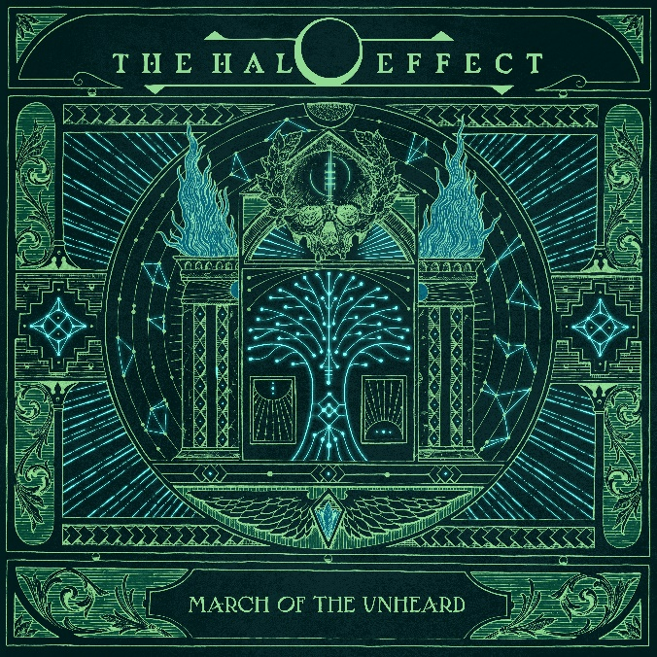

**THE HALO EFFECT**

**»March Of The Unheard«**

##### OUT: January 10th 2025

|  |  |
| --- | --- |
| **Line up:** | **THE HALO EFFECT online:** |
| Mikael Stanne | Vocals  Niclas Engelin | Guitar  Jesper Strömblad | Guitar  Peter Iwers | Bass  Daniel Svensson | Drums | [facebook.com/thehaloeffectse](https://www.facebook.com/bleedfromwithinband)  instagram.com/thehaloeefctse/  [twitter.com/thehaloeffectse](https://twitter.com/BleedFromWithin) |

**THE HALO EFFECT** may have begun as five old friends just making music for fun, but they’re now one of the most beloved new bands in heavy metal. Before the Swedish quintet even formed, their members were heroes of heaviness, key in establishing melodic death metal’s much-imitated ‘Gothenburg sound’ during the ’90s. Then, when the longtime scenemates finally united and released debut single **'Shadowminds'** in 2021, they quickly racked up millions of streams. Their subsequent debut album, ***Days of the Lost***, was nominated for a Swedish Grammy and promoted on tours with Machine Head, Amon Amarth and Meshuggah. It then won the Rising Star trophy at the 2024 Metal Hammer Awards. This collective’s ascent has been as rapid as it has been well-deserved.

*“What I loved about the first album with THE HALO EFFECT was that it was just new,”* says **singer Mikael Stanne**, also esteemed for his decades of work with melodeath frontrunners Dark Tranquillity. *“We didn’t know what we wanted to do. It was just for fun, to amuse ourselves and each other. But then you have to do a followup to an album that was named album of the year here in Sweden by our biggest magazine. It’s like, ‘OK, how do we do that?’”*

Evidently, the answer was for the band to both adhere to their roots and broaden their vision. ***March of the Unheard*** is a triumphant successor brimming with everything that made ***Days Of The Lost***an instant breakthrough. The likes of **'Detonate'** and **'What We Become**' bear all the hallmarks of the Gothenburg sound, flaunting the slicing guitar leads, energetic percussion and shoutalong hooks that have made it addictive for generations of metalheads. Other standouts build on those infectious foundations. '**Between Directions**', for example, adds orchestral strings that feel right at home in **THE HALO EFFECT**’s high-energy wheelhouse. Proggy synths wobble at the start of opener '**Conspire to Deceive**', '**Our Channel to the Darkness**'explodes from pensive acoustic guitars to full-blown metal and '**Coda**' ends ***March Of The Unheard***with a choral and symphonic instrumental. Plus, throughout the album, **Mikael** makes extra use of his gracefully melodic singing.

*“I felt more confident this time around,”* explains guitarist **Niclas Engelin**, who co-writes **THE HALO EFFECT**’s music with fellow instrumentalists **Jesper Strömblad** (guitars), **Daniel Svensson** (drums) and **Peter Iwers** (bass). *“For the first song with THE HALO EFFECT, we didn’t know where to go. We were talking about Rush and progressive music, or maybe we should go Tom Petty. But then Peter had the idea for the opening of [*Days of the Lost *song] ‘Gateways’, and then we did ‘Shadowminds’ and ‘Feel What I Believe’. We were like, ‘Alright! Let’s not search anymore! Let’s just go for it and not overthink.’ We used that rule on this album. It’s more progressive, with more guitars, more riffage – it’s more of everything, in a way.”*

Lyrically, **Mikael** has also expanded on the ideas he presented with ***Days Of The Lost****.* The debut explored the members’ near-lifelong relationship with metal, from first falling in love with it to the highs and lows of playing in a veteran band. ***March Of The Unheard***, on the other hand, zeroes in on life as a young outcast with a fixation on music. *“Let us reach for every instrument that will amplify our anger!”* **Mikael** roars during the album’s whirlwind title track. *“There are ways to wander beyond the given path,”* declares anthem for the rebels **'Cruel Perception**' whereas **'Forever Astray**' points towards teenage self-discovery with, *“We look inside just to find ourselves out.”*

*“When we started THE HALO EFFECT, I wanted to write about what it was like when we were kids, when we started hanging out together at 14 or 15 years old,”* **Mikael** says. *“Maybe we weren’t the people who were chosen for the football team or whatever. We turned to music to find our identity. My thinking was like, ‘What if that didn’t happen?’ I’m trying to live vicariously through our collective kids who are around that age now, seeing how difficult it can be to try and be part of something you don’t fully understand yet. That’s an underlying theme behind this album.”*

Work on what would become ***March Of The Unheard***started before **THE HALO EFFECT** had even played a gig. *“Our first-ever show together was at Sweden Rock festival on the big stage – we had one hour and the album was 41 minutes,”* **Niclas** laughs. *“I had this idea for an acoustic intro kind of thing, and that, for me, was the starting point of writing the next album. We made it a song, a theme, and actually end the album with it. Mikael called it ‘Coda’.”*

Writing carried on consistently from there, until **THE HALO EFFECT** re-entered Crehate Studios with producer **Oscar Nilsson**, a longtime collaborator of **Niclas**’. What the band have emerged from those sessions with is undoubtedly their strongest material yet. ***March Of The Unheard*** isn’t just another opus of Gothenburg melodeath; it announces that **THE HALO EFFECT** still have fresh ideas for the genre, 30 years after their members helped catapult it to international acclaim. Now united under one banner, they are gunning for global success once again.

**– Matt Mills, August 2024**